Plan for learning through Music (Wominjeka Song)
Learning Intention: For the children to see greetings in Aboriginal culture as well as become familiar with the importance of land and water for Aboriginal people through singing Wominjeka song. Also, for the children to be able to tap on their lap while singing the song.
OUTCOME 2: CHILDREN ARE CONNECTED WITH AND CONTRIBUTE TO THEIR WORLD (The Early Years Learning Framework [EYLF] 2009)
Who: The whole group of the four-year-old group during mat time. This group of children is multicultural and they had several different learning experiences about diversity and self-identity throughout the term. They are familiar with the concept that people are coming from different places and, they use to say hello and goodbye to their friends in their home language. Having this in mind, they appear to be ready to know about the Aboriginal culture in a meaningful way during the reconciliation week.
Where: On the mat where all the can sit in a big circle.
Materials: Please visit my WIX website on Music | Arts Portfolio (wixsite.com)
Procedure – Provocations and prompts:
- Children are asked to take each other’s hands and make a circle and then let their hands go and sit down.
- I would make the river while telling them that I want to read a special book for them. To engage them more, I would ask them some questions to recall their previous learnings about greetings in different languages. Some children can say hello or welcome in their home language if they wish to (as they normally do), if no one was interested in doing this, I would say hello and welcome in the languages that I know (Farsi: Salam, Khoshamadid/Arabic: Salam, Ahlan wa sahlan/ French: Bonjour, Bienvenu). By now they are ready to know that how Aboriginal people use to say greetings/welcome to each other.
- Then I would read the book Welcome to Country by Lisa Kennedy for them as a provocation.
- They can see the word and listen to it and repeat it.
- I would sing the Wominjeka song for them and they will join me. I would then start tapping in my lap to model for the children.
- Then children of one side of the river greet the other side and vice versa by singing Wominjeka.
- After mat-time, the river would be transferred to a table/lightbox for the children to enjoy playing with it and extend their learning.
Differentiation strategies: Apply an inclusive lens:
- Acknowledging children’s family and home language prior to teaching them about new a culture is an example of being inclusive.
- Using body percussion is an appropriate choice for children with poor hand-eyed coordinations (Dinham and Chalk, 2017).
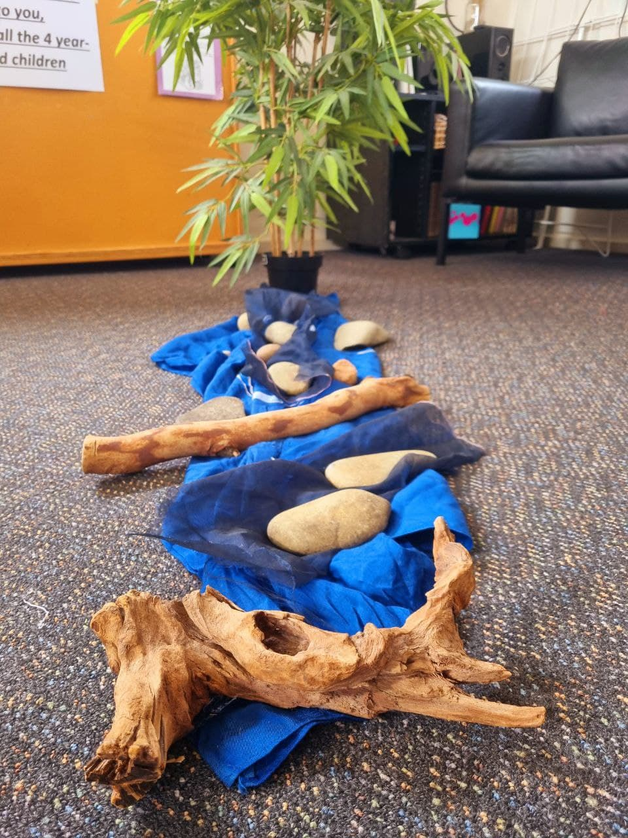
- The one-word song provides an opportunity for all the children to participate, and because it is a new song and language for everyone EVERY child has the same opportunity to participate. It is significantly important for children with English as an additional language ( the majority of the children in this group are coming from non-English speaking families).

